*Car Door Embedded Static Analysis Design*

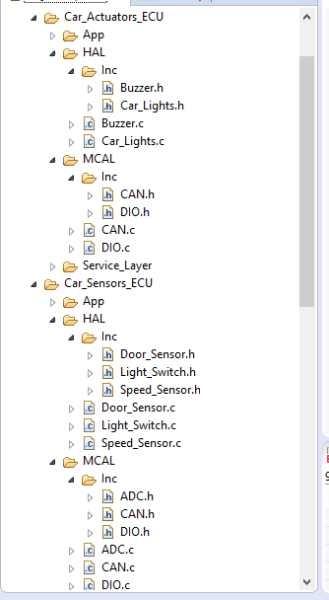

Figure (1) the Overall Static Analysis Overview

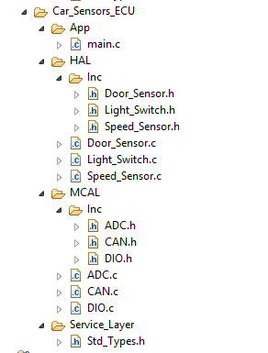

Figure (2) ECU 1 (static Design)

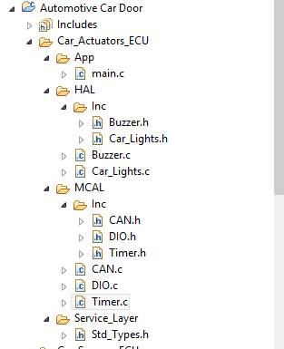

Figure (3) ECU_2 (Static Design)